A Software Design Specification Template

by Areeba Arshad BSSE02153060
Hadayatullah Hammad BSSE02153184
Nida Khalid BSSE02153212
Syeda Sibra Batool BSSE02153206
Sara Tehseen BSSE021532

Table of Contents
1. Introduction 1
1.1. Document Outline 2
1.2. Document Description 4
1.2.1. Introduction 4
1.2.2. System Overview 5

2. Design Considerations 5
2.1. Assumptions and Dependencies 5
2.2. General Constraints 5
2.3. Goals and Guidelines 6
2.4. Development Methods 6
3. Architectural Strategies 6
4. System Architecture 7
4.1. Subsystem Architecture 8
6. Detailed System Design 9
6.1. performance 9
6.2. Error handling 9
6.3. Installations 10

7. Bibliography 11

Introduction:

Hospital is an organization that mobilizes the skills and efforts of a widely divergent group of professionals, semi-professionals, professional’s personnel, to provide highly personalized personnel services to patients .World health Organization (WHO) has defined hospital as an integral part of social and medical organization that provides the complete curative and preventive health care and treatment to people. There are computer software products that coordinate and integrate all the inherent activities involved in the management and running of a healthcare facility.

Document Outline

Document Description

Introduction

Purpose
This Software Design document is made with the purpose of outlining software design & architecture of Health Management System. The document will provide developers an insight in meeting client’s needs efficiently. The document facilitates communication & understanding of system by providing several views of system design.

Scope
This Software Design document demonstrates how design will accomplish functional & non-functional requirements captures in SRS. The documents will provide a framework to developers through describing high level components, sub-system, interface & designs. This is achieve through the use of architectural patterns, sequence diagrams, class diagrams & user interfaces.
Intended Audience
This document is mainly for developers & technical staff of OBAX software house for developing Health Management system.

System Overview
The Health Management System is created to computerize manual operations in clinics. The objective of the software is to digitize patient records so as to make data retrieval easy and efficient. The admin registers patients so they can book appointments easily according to their convenience. Being in the digital form, patient data can be conveniently shared and accessed by multiple simultaneous users at different locations, resulting in smoother clinical operations and collaboration among clinicians. It also means that patient data can be easily backed up, and be protected for confidentiality and from tampering through access control. In addition, clinical tasks involving panel billing, inventory management and accounting are all made easy, and in some manner automated. It is a web application that will be easy to use by doctor & patients. Health Management System will provide an interface in which a patient can view their medical history & doctor can update, delete, view patient’s information.

Design Considerations:

This section describes many of the issues which need to be addressed or resolved before attempting to devise a complete design solution.

2.1. Assumptions and Dependencies
The assumptions or dependencies regarding the system Health Care System or the assumed factors are :

DATABASE:
The system shall use the MySQL Database, which is open source and free. Healthcare system assumes that there will be a database of medical records hosted by a server. The server assumes it will be installed with a high-speed Internet connection to communicate with Healthcare system users.

APPLICATION:
Healthcare application is a Web-based. Healthcare application will run on the user’s iphone or iPod , android and desktop computers. Full functionality of Healthcare application will depend on the availability of an Internet connection. The web version of Healthcare application will run on the user’s computer. The use of this web-based application will completely depend on an Internet connection.

OTHER ASSUME FACTORS:
- The code should be free with compilation errors/syntax errors.
- The product must have an interface which is simple enough to understand.
- Internet from either a cellular or Wi-Fi connection to establish a connection between the application and the medical record repository.
- The website should be responsive and interactive enough .

2.2. General Constraints
The global limitations or constraints that have a significant impact on the design of the system Healthcare management (and describe the associated impact).
(TIMING CONSTRAINT)The system must be delivered on time.
The existing Telecommunication infrastructure is based on IEEE100802.3 standards and the system must conform to this standard.The system must be user-friendly (ease of use).

1) User Interfaces:
Clinic Portal: As a web-based application, will be the primary channel through which users access or modify any information in the database.
- (GUI) Graphical user interface

2)Hardware Interfaces:
The healthcare application requires an external fingerprint scanner supported by the custom version of Person ID.

3) Software Interfaces:
- Clinic Portal to Database
- Application to Database
- Person ID to Database

3)Software Interfaces:
The software provides a good graphical interface for the user any administrator can operate on the system, performing the required task such as create, update, delete, and view his own details and records.

4)Communications Interfaces or Protocol requirements:
The database will communicate via an encrypted remote connection using SSL.

5) Performance requirements:
- The database shall be available 99% of the time during business hours.
- The database shall be available 95% of the time during non business hours.
- No Database query shall take more than 5 seconds with only one database connection active.
- No page shall ever take more than 5 seconds to access.
- Fingerprint scanning shall return results within 1 second

6)Safety Requirements:
- Data from the database will never be transmitted to unauthenticated sources.
- Healthcare application will never disclose patient information to users that are not authorized to see it.
- There must not be any unauthorized use of patient or doctors record so there must be high level of safety for them.

7)Security Requirements:
- Must provide high level of security for all members of system.
- The database must be encrypted at rest
- All request and data transfer between the server in the database must be done over an SSL connection.
- All patient information stored locally on the computer running on application

8)Quality Attributes or goals:
- Database is normalized.
- Clinician application is rated at ⅘or above by at least 90% of clinicians for ease of learning.

2.3. Goals and Guidelines

Need skills to manage the place of healthcare technology in the health system. Therefore, Healthcare management system means managing how healthcare technology should interact and balance with your:
- medical and surgical procedures
- support services
- consumable supplies, and
- facilities etc

So that the complex whole enables you to provide the health services required.
Thus HTM is a field that requires the involvement of staff from many disciplines – technical, clinical, financial, administrative, etc.

Guidelines:
Looks at how to ensure your Healthcare Management system(HMS) Teams carry out their work in an economical way, by giving advice on financial management.
resource materials which will help health staff with the daily management of healthcare technology.
Guides cover a range of tasks and It has a very wide application; for example equipment is used to:
- help diagnose whether a patient has malaria
- treat a patient by removing their gall stones
- monitor the condition of a patient’s heart
- feed patients and staff
- provide clean surroundings.
- control the environment by supplying heat and light etc

2.4. Development Methods
Discuss the development of a web application from scratch.
A high priority demand as a sub part for this web application will be the concept of patient’s appointments. A high priority demand as a sub part for this web application will be the concept of patient’s appointments.
It serves to build a health management information system from basic principles and covers all the software engineering activities starting from the gathering of requirements, evaluating these and eventually implementing a health management information system by applying several iterations of the Agile-extreme-programming-software-engineering approach to develop a Health Management System.
METHODS:
- Agile methods
- Agile processes
- Agile method techniques
- Extreme programming ( XP is a sub method of Agile methods. XP has multiple steps. Planning is the first step in developing the HMIS. Our planning was based on user stories achieved from a survey and questionnaires. The other steps are design, code and test)

3. Architectural Strategies:

Architecture of the healthcare management system is designed in a way like
First we discuss the data , which has to be processed in hospitals and then present hospital functions interpreting and updating these data.
Typical information processing tools will be used and typical architectures first at logical then at the physical layer of hospital information systems.
At each layer these tools can be assembled and integrated for better support of users.
Design decisions might concern (but are not limited to) things like the following:
Use of a HMS as a product:
- Programming language- php
- Database- My-sql
- Libraries- JQuery and JavaScript

Error detection and recovery:

The Data Link layer performs error detection . Networks often use cyclic redundancy check (CRC) algorithms to find corrupted data at this level. The Transport layer handles error recovery.

Communication mechanisms:

It will use protocols TCP/IP for communication and the database will communicate via an encrypted remote connection using SSL.

Management of other resources:

Some levels are responsible in managing the recourses used in healthcare management system. Have a accepted architecture strategy for a system is absolutely critical to your success, particularly in the complex situations which agile teams find themselves in at scale. Scaling issues include team size, regulatory compliance, distributed teams, technical complexity, and so on .

3.1 System Architecture

This section should provide a high-level overview of how the functionality and responsibilities of the system were partitioned and then assigned to subsystems or components. Don't go into too much detail about the individual components themselves (there is a subsequent section for detailed component descriptions). The main purpose here is to gain a general understanding of how and why the system was decomposed, and how the individual parts work together to provide the desired functionality.

At the top-most level, describe the major responsibilities that the software must undertake and the various roles that the system (or portions of the system) must play. Describe how the system was broken down into its components/subsystems (identifying each top-level component/subsystem and the roles/responsibilities assigned to it). Describe how the higher-level components collaborate with each other in order to achieve the required results. Don't forget to provide some sort of rationale for choosing this particular decomposition of the system (perhaps discussing other proposed decompositions and why they were rejected). Feel free to make use of design patterns, either in describing parts of the architecture (in pattern format), or for referring to elements of the architecture that employ them.

If there are any diagrams, models, flowcharts, documented scenarios or use-cases of the system behavior and/or structure, they may be included here (unless you feel they are complex enough to merit being placed in the Detailed System Design section). Diagrams that describe a particular component or subsystem should be included within the particular subsection that describes that component or subsystem.

Note:
This section (and its subsections) really applies only to newly developed (or yet-to-be developed) portions of the system. If there are parts of the system that already existed before this development effort began, then you only need to describe the pre-existing parts that the new parts of the system depend upon, and only in enough detail sufficient to describe the relationships and interactions between the old parts and the new parts. Pre-existing parts that are modified or enhanced need to be described only to the extent that is necessary for the reader to gain a sufficient understanding of the nature of the changes that were made.

3.2 Subsystem Architecture

If a particular component is one which merits a more detailed discussion than what was presented in the System Architecture section, provide that more detailed discussion in a subsection of the System Architecture section (or it may even be more appropriate to describe the component in its own design document). If necessary, describe how the component was further divided into subcomponents, and the relationships and interactions between the subcomponents (similar to what was done for top-level components in the System Architecture section).

If any subcomponents are also deemed to merit further discussion, then describe them in a separate subsection of this section (and in a similar fashion). Proceed to go into as many levels/subsections of discussion as needed in order for the reader to gain a high-level understanding of the entire system or subsystem (but remember to leave the gory details for the Detailed System Design section).

If this component is very large and/or complex, you may want to consider documenting its design in a separate document and simply including a reference to it in this section. If this is the option you choose, the design document for this component should have an organizational format that is very similar (if not identical to) this document.

4.System diagrams:
4.1 Class diagram:
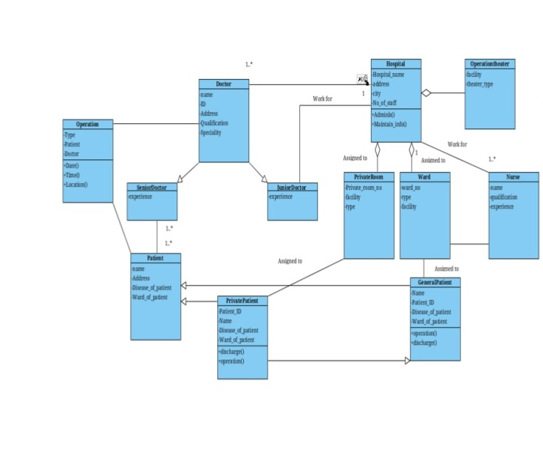

4.2 Activity diagram:

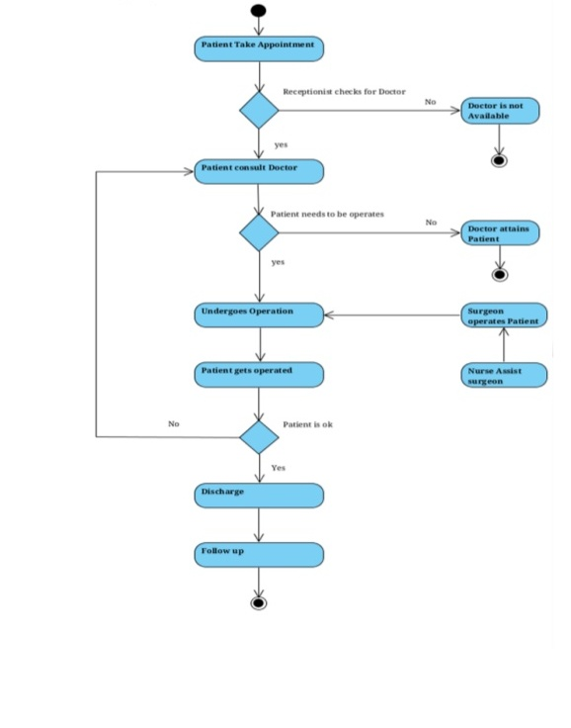

4.3 use case diagram:

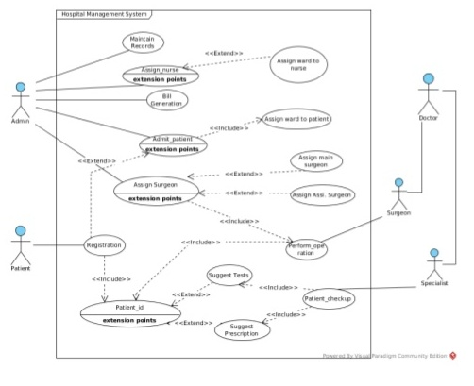

4.4 Deployment diagram:

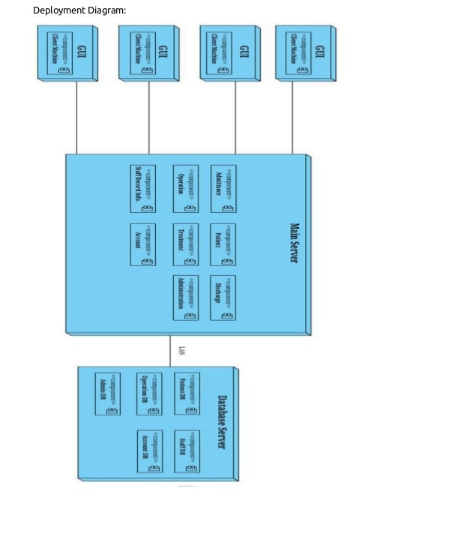

4.5 component diagram: 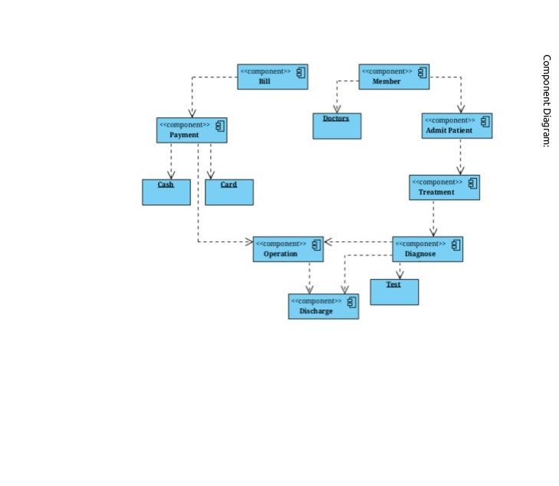

4.6 State diagram:

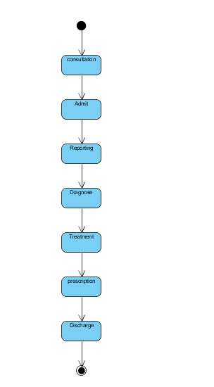

6. Detailed System Design:
Some of the details of system’s components are required that are as follows :

6.1: Performance requirement :
For any software developed in this modern time, one of the most important things to do regularly is to update and upgrade and fix whatever bugs found. The following are the list of maintenance required for this software:
- Database archiving •
- Password encryption •
- Anti-virus protection. •
- Password update every 72 days 4.3

6.2: Error handling:
The system also has error and debugging code within the software to prevent system collapse and krypton 2 professional encryption programs is embedded within the software security layer to prevent hacking it when installed over internet network. Also, within the code itself, SQL inject susceptible characters had being cleaned up.

6.3: Installation:
After developing and testing the software, the next thing is to deploy the software and run it. For the purpose of this thesis, the installation and deployment of the software will be done from a compact disc (CD) from which the software had been copied to and will be run on a window platform.

7- Bibliography:

Spriestersbach, A. (2009) Component Design and Open Specification (Resource development and Management), Seventh Framework Program. FPF-ICT-2009-5. A research sponsored by the European Union.

URL:http://4caast.morfeoproject.org/wpcontent/uploads/2011/09/4CaaSt_D4.2.1_Compo nents_Design_and_Open_Specification.pdf. (Quoted, 18.05.2012)

Royce, W (1970). Managing the development Of Large Software System. IEEE WESCON proceeding page 1-9 Archer, P. (2009) Personalized Access to Cultural Heritage Space.

Project sponsored by European Union. Grant agreement number: ICT-2009-270082 Nielsen, J., and Molich, R. (1990). Heuristic evaluation of user interfaces, Proc. ACM CHI'90 Conf. (Seattle, WA, 1-5 April), 249-256. Quoted: 03.03.1990

